2018-07-02

TO DO LIST:

Get familiar with ToF sensor/ setup/ wavelength

Build the projector

Understand the mechanism of each step, including how to use triangulation to estimate depth in one camera one projector system, how to deal with the noise appearing in the measurement, how distance between camera and projector influence the unique depth range and depth resolution, how to design structure light

How tof works/ how triangulation works

2018/07/10

Finish the equation for temporal and spatial modulated light.

2018/07/11

Currently, the plan is that we need to phase shift 3-4 times spatially, and for each pattern, we use the time-of-flight to get the coarse depth. The reason for this is: if we use the sinusoid pattern to illuminate the object, after several times temporal modulation, we could get the background illumination(bias), time-of-flight depth (bright region) and the product of reflectivity and pattern. Thus, we need at least one more pattern to determine the reflectivity and pattern, and also, in order to determine the phase of each pixel, we need at least two more measurements. In conclusion, for now, we need at least three times measurement to realize the 3d reconstruction.

2018/07/17

The parameter of DMD

Bit per second: 115200

Data bits: 8

Stop bits: 1

Resolution inputs: 1280x800, 1024x768, 1024x640, 912x1140, 800x600, 800x500 and 640x480 120Hz; For VIDEO MODE, input resolution will be the native resolution (912x1140); For PATTERN SEQUENCE MODE, input supports 912x1140

DMD: 0.45 inch, each mirror 7.6um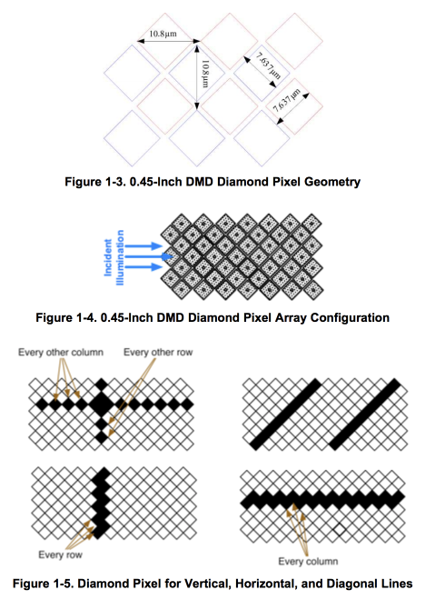

2018/7/18

parameters for ToF camera:

image array: 320x240

pixel pitch: 15um (3.6mm-4.8mm)

optical properties: 0.35A/W at 850nm, 45% contrast at 50MHz, frequency from 10MHz to 100MHz

2018/07/26

task: figure out how to use/control DMD

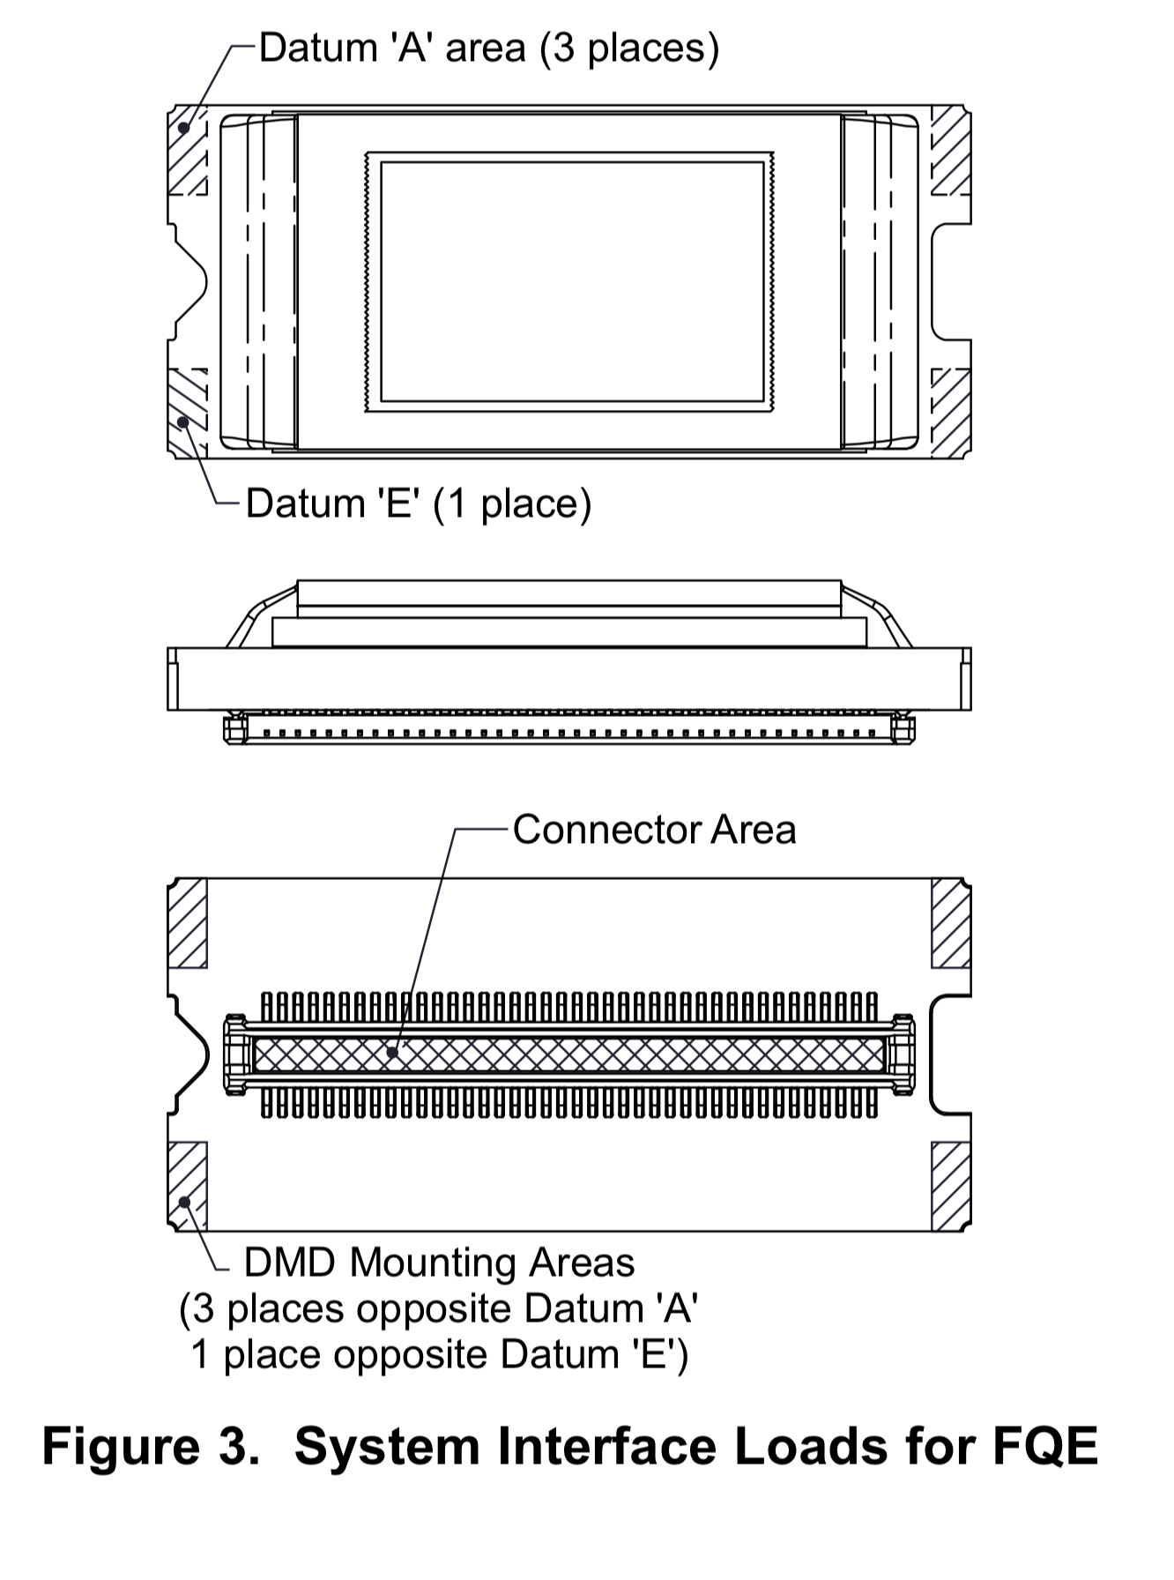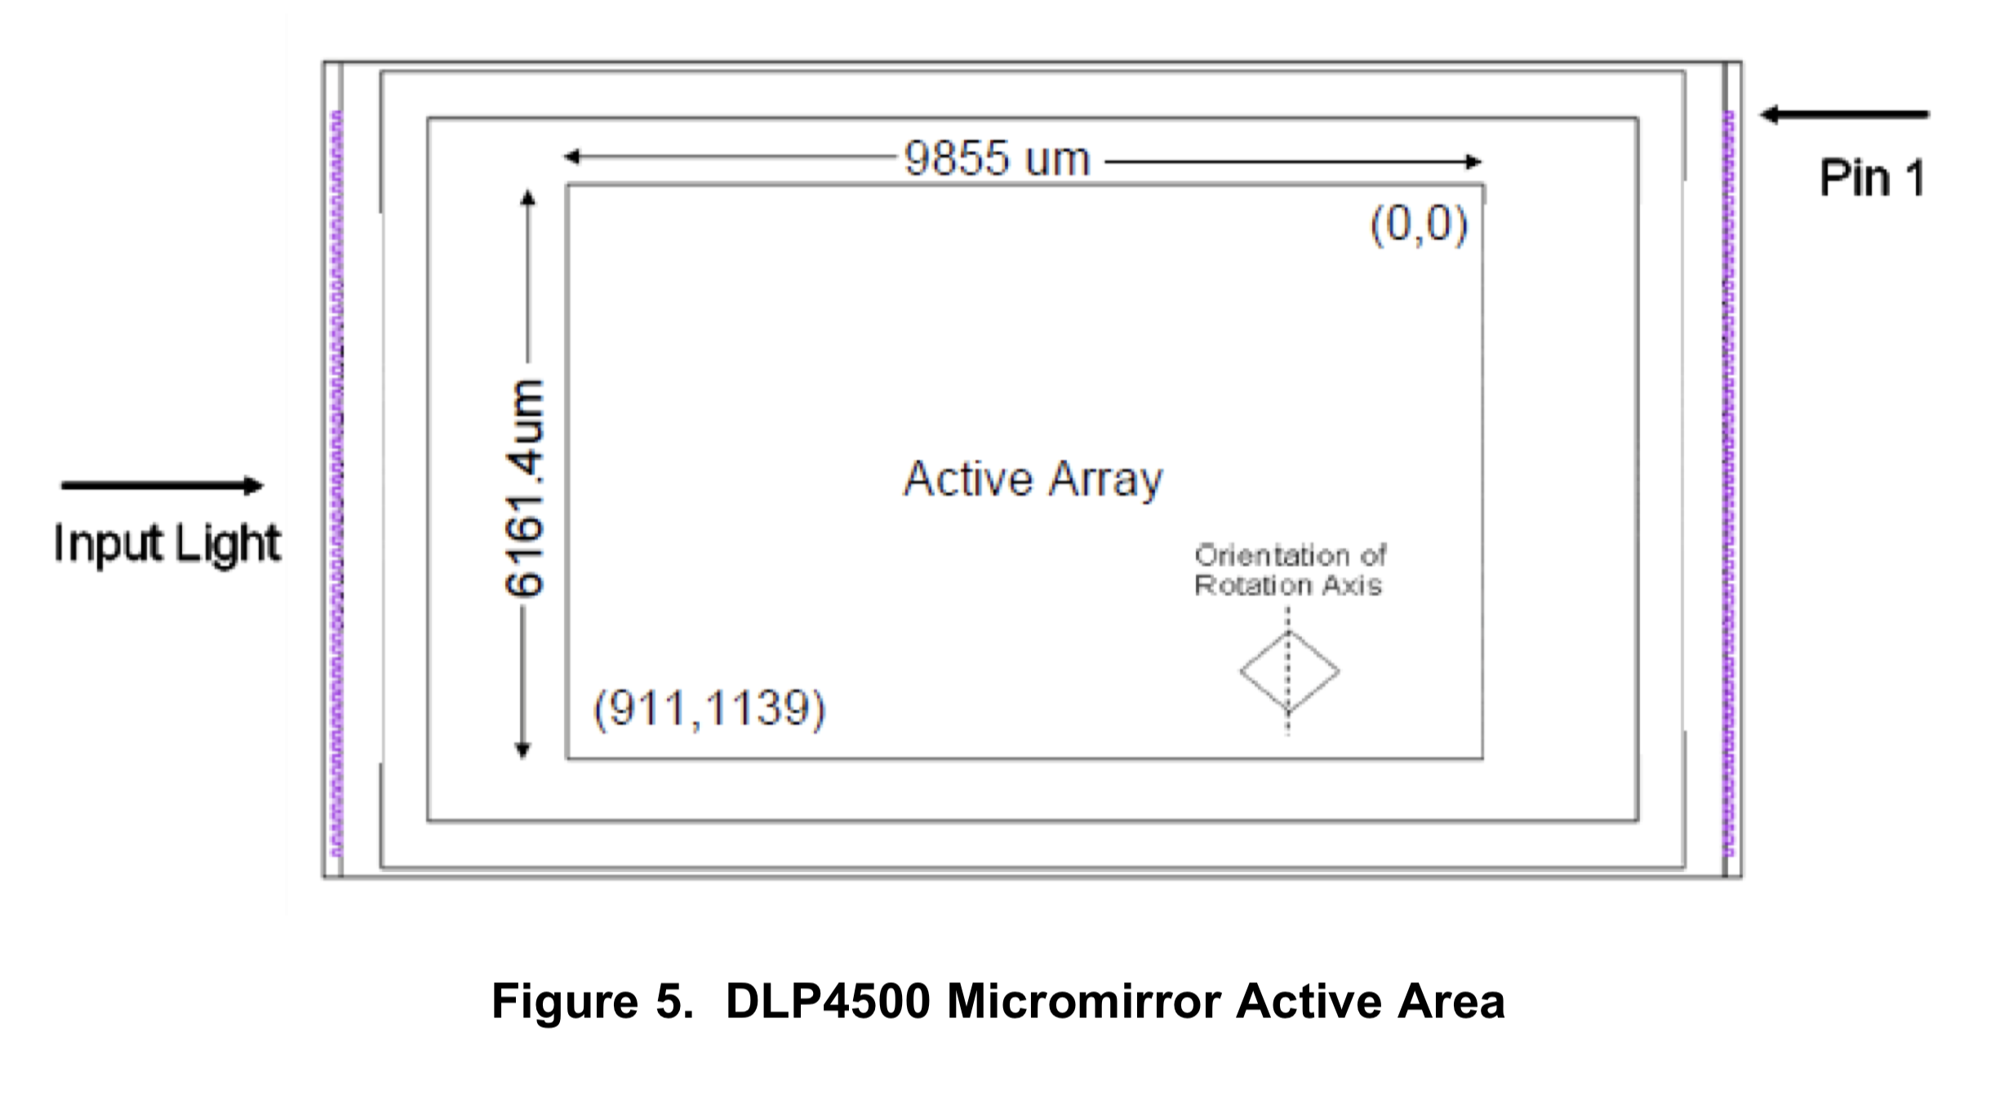

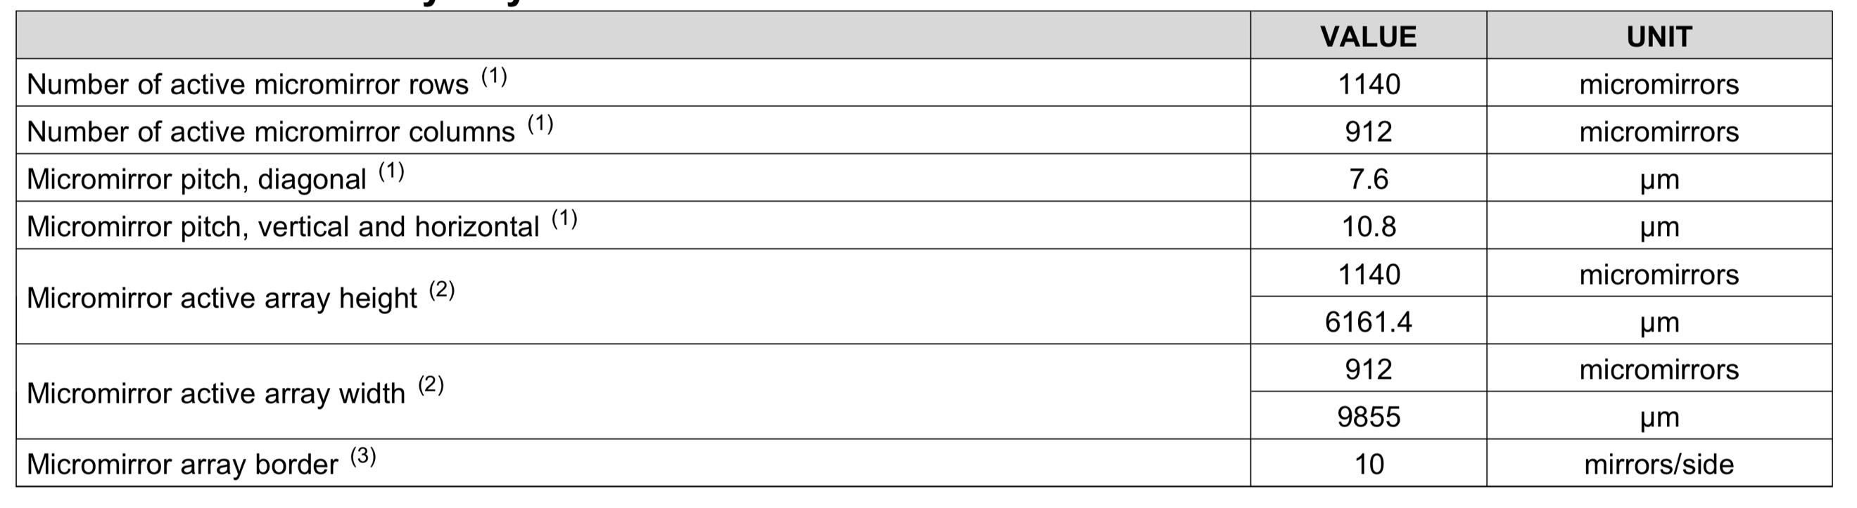

2018/08/15

tof sensor size = 7.859*8.757mm

filter = 830-867nm

https://www.thorlabs.com/newgrouppage9.cfm?objectgroup_id=4791

condensed lens1: **ACL12708U-B**

<https://www.thorlabs.com/newgrouppage9.cfm?objectgroup_id=3835&pn=ACL12708U-B>

condensed lens2: **ACL2018U-B**

projective lens: MVL100M23

/objective lens: [**MVL4WA**](https://www.thorlabs.com/thorproduct.cfm?partnumber=MVL4WA)/[**MVL5WA**](https://www.thorlabs.com/thorproduct.cfm?partnumber=MVL5WA)

https://www.thorlabs.com/newgrouppage9.cfm?objectgroup_id=1822